# Git Assignment-4

## Put master.txt on master branch, stage and commit

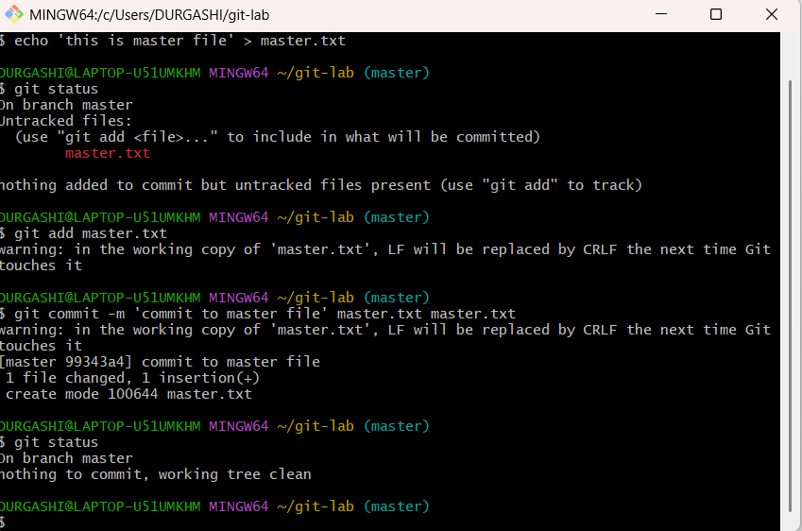

## Create 3 branches: public 1, public 2 and private

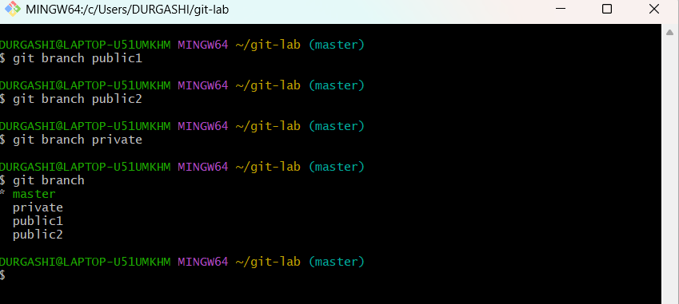

## Put public1.txt on public 1 branch, stage and commit

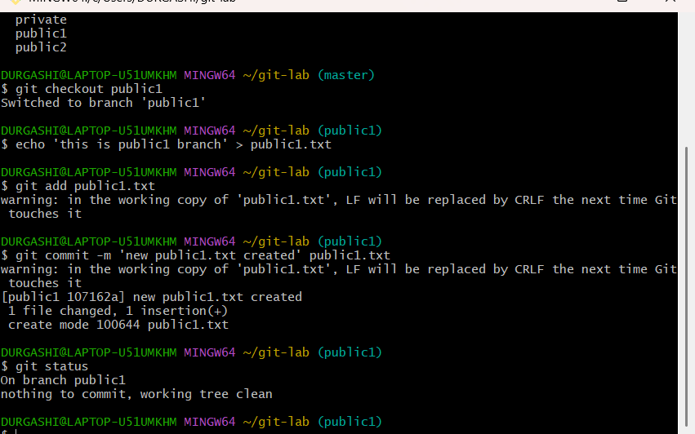

## Merge public 1 on master branch

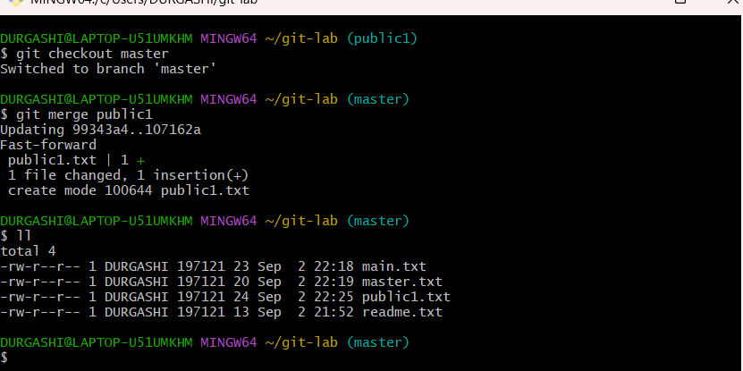

## Merge public 2 on master branch

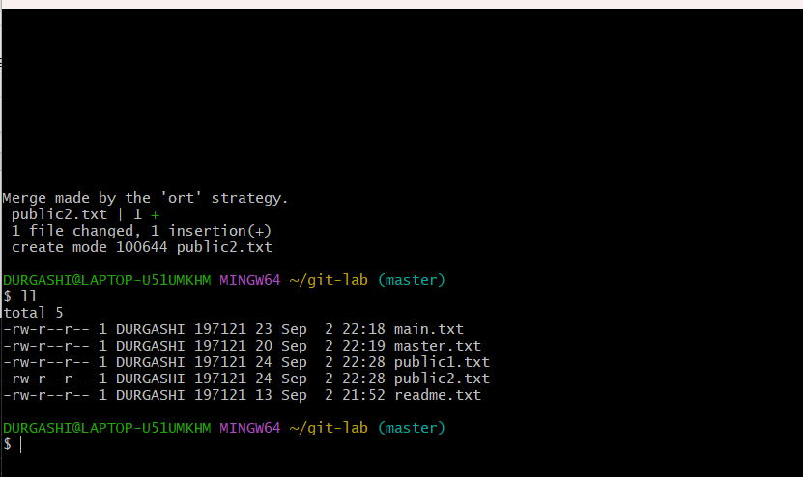

## Edit master.txt on private branch, stage and commit

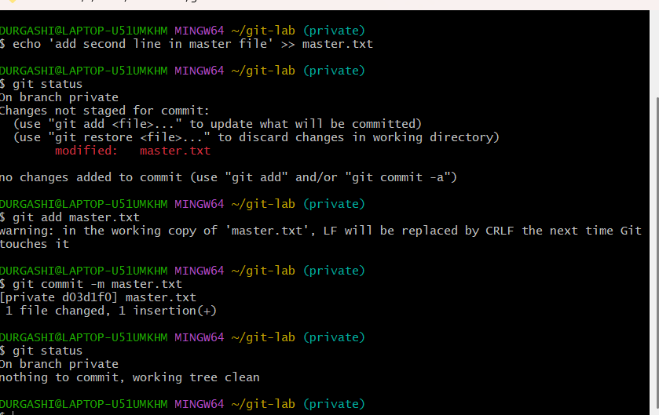

## Now update branch public 1 and public 2 with new master code in private

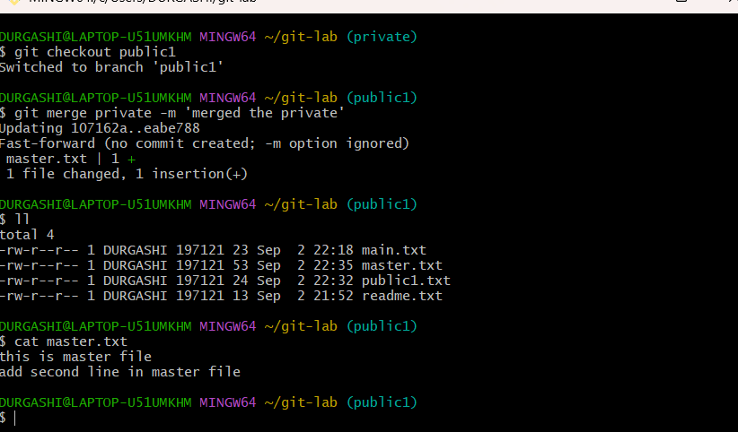

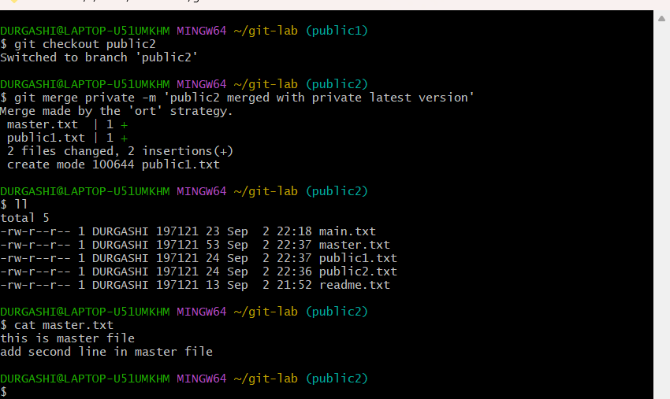

## Also update new master code on master

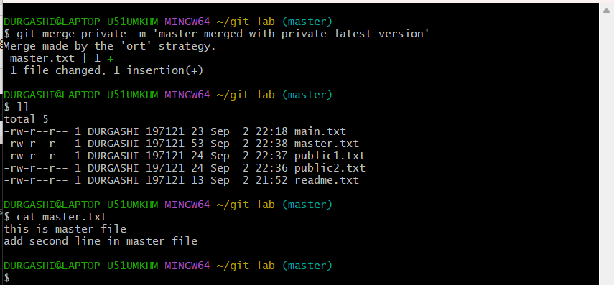

## Finally update all the code on the private branch

